**EXPERIMENT NO. 5**

**Create a simple Testing Angular application**

**Title :** Create a simple Testing Angular application

**Aim :** Implementation of a simple Testing Angular application

**Theory:**

What is AngularJS

Angular JS is an open source JavaScript framework that is used to build web applications. It can be freely used, changed and shared by anyone.

Angular Js is developed by Google.

It is an excellent framework for building single phase applications and line of business applications.

Advantage of AngularJS

There are a lot of JavaScript frameworks for building web applications. So, it is a genuine question, why to use Angular JS.

**Following are the advantages of AngularJS over other JavaScript frameworks:**

* **Dependency Injection:** Dependency Injection specifies a design pattern in which components are given their dependencies instead of hard coding them within the component.
* **Two way data binding:** AngularJS creates a two way data-binding between the select element and the orderProp model. orderProp is then used as the input for the orderBy filter.
* **Testing:** Angular JS is designed in a way that we can test right from the start. So, it is very easy to test any of its components through unit testing and end-to-end testing.
* **Model View Controller:** In Angular JS, it is very easy to develop application in a clean MVC way. You just have to split your application code into MVC components i.e. Model, View and the Controller.
* Directives, filters, modules, routes etc.

AngularJS MVC Architecture

MVC stands for Model View Controller. It is a software design pattern for developing web applications. It is very popular because it isolates the application logic from the user interface layer and supports separation of concerns.

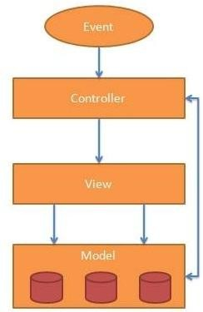

The MVC pattern is made up of the following three parts:

1. **Model:** It is responsible for managing application data. It responds to the requests from view and to the instructions from controller to update itself.
2. **View:** It is responsible for displaying all data or only a portion of data to the users. It also specifies the data in a particular format triggered by the controller's decision to present the data. They are script-based template systems such as JSP, ASP, PHP and very easy to integrate with AJAX technology.
3. **Controller:** It is responsible to control the relation between models and views. It responds to user input and performs interactions on the data model objects. The controller receives input, validates it, and then performs business operations that modify the state of the data model.

**Conclusion:**

Thus, we have studied the implementation of a simple Angular application